Scheduled for Wednesday at 1:00 am 11/12 (Set at 6:04 am 11/11)
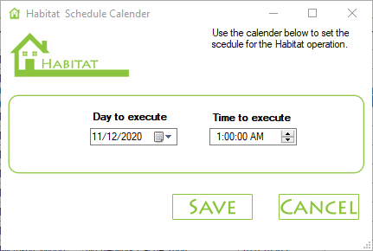

Script did not run


