How to use Patch Remedy


Version 1.0.0
Date: 6/28/2017
If you have a chance to review our engineer's demo video, it provides a great understanding of the basics of Patch Remedy, although it is starting to show its age as Patch Remedy has had many improvements since that video, but the basics haven't changed.

https://www.plugins4labtech.com/products/patch-remedy at the bottom of product page.

We also have the quick start guide to get you setup correctly at https://www.plugins4labtech.com/pages/patch-remedy-quick-start-guide

A little bit about Patch Remedy

Patch Remedy is a set of tools and automations that attempt to update your Windows systems WUA to the latest known versions and thus allowing Windows and LabTech to pro-actively apply patching policies you approved in LabTech. This automation requires that you have a liberal reboot schedule setup and are monitoring progress through the "HotFix Issues" tab under the RT column for systems with counts over (3). Any system with a RT count of 3 or more will no longer run any automation until cleared! This prevents Patch remedy from repeatedly pushing an update to the agent after so many tries(3). By clearing this you are allowing it to return to normal operation for those agents cleared.
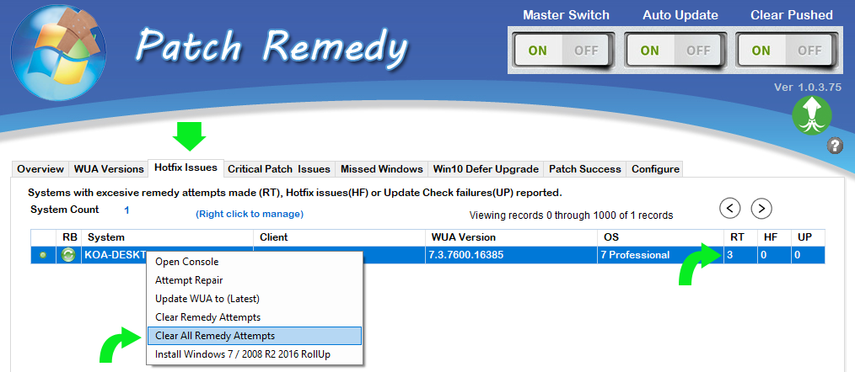
An example Windows 7 agent
A Windows 7 SP1 at WUA version less than 7.6.7601.23453 would have the KB3020369 update applied during the first scan cycles. This will bring Windows 7 to 7.6.7601.23453 once you have rebooted the system, but not until that reboot happens. Once the reboot takes place and the PR scanner runs again we will see that Windows 7 has updated and we will push the next update to get to step 2. We will see that the Windows 7 system is less than 7.6.7601.23714 and we will apply KB4012218 to bring it up to 7.6.7601.23714, of course once the reboot has happened. The scanner runs again and we see it now has updated to 7.6.7601.23714 and we repeat the steps again until the system reaches the current WUA which is 7.6.7601.23806 as of (June 2017). Reboots must happen between each set of steps for the automation to work and move on to the next update.

Windows 7 SP1 may require up to the following updates to get to the current WUA build. Each update must have a reboot between it, then to allow the Patch Remedy Scanner to rescan before you will see it show as updated. This could take 5 or more passes if you are rebooting daily or If you are rebooting weekly it could take 5 weeks. Plan accordingly!

KB3020369 < 7.6.7601.23453
KB4012218 < 7.6.7601.23714
KB4015549 < 7.6.7601.23735
KB4019265 < 7.6.7601.23775
KB4022722 < 7.6.7601.23806

Now that you know what it's trying to do, here is how you can make it work without your finger on its throat.
Reboots required
We provide a "Pre-Maintenance Reboot" feature if you use maintenance windows in Labtech, most MSPs I have helped do not use Maintenance Windows in LabTech so it's not uncommon if you do not. We use maintenance windows as a trigger to force systems that show they need a reboot to reboot. Based on the maintenance window frequency this is a good alternative if setup correctly. The second option is to use the LabTech Reboot script provided by LabTech or create your own reboot script to reboot Windows systems that show the reboot flag on nightly. This will allow Patch remedy to update the system the following day and the cycle will repeat until they are all up to date. By using the reboot flag as the indicator that the reboot needs to happen you will not just reboot all Windows daily, just the ones that show they are pending.

Lastly you should set the scanner interval to 8 or 12 and then visit once a day for the next 5 days the "Hotfix Issues" Tab to "clear out all remedy attempts" on the top data view. This frees up any agents that have repeatedly tried to install a update and has reached a count of 3 or more. By releasing them, they can rejoin the automation process and move to the next update.

After 5 days, you should see a huge improvement in your Update counts and the main bar graph should start to get smaller brick sizes.

Not over to the fat lady sings
You made it! You have crossed over the 90% mark but wait, it doesn’t end there, the very next month Microsoft will release a new WUA version which upon the first agent installing it will cause your newly achieved score to plummet. All the Windows systems will show out of date until that next round is applied. We update Patch Remedy almost weekly covering any updates the Microsoft released that effects WUA. Make sure your Patch Remedy stays up to date by checking every so often against our products page to see if version numbers have changed. Patch Remedy should auto update but at times Labtech has been known not to do it. So, checking our versions on occasion would be useful.

